MY MOVIE PLAN

(AN ONLINE TICKET BOOKING WEB APP)

GITHUB LINK: https://github.com/AnishAugustin09/My-Movie-Plan

**This document contains the:**

* Sprint Planning
* Flow of Project
* Concepts used in Project
* Working on Eclipse IDE
* Conclusion

**Sprint Planning:**

For this project, I’ve planned to complete the project in 4 Sprints. And the task is completed according to that. And This is a Full Stack Java Project so Backend & Frontend Technologies used here

**Flow of Project:**

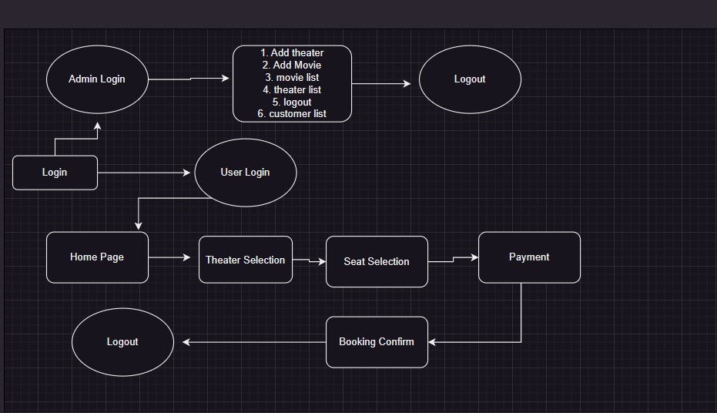

**Project Flow:**

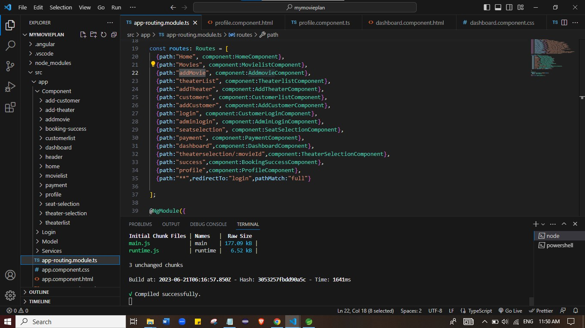

**Concepts used in Project:**

* HTML, CSS & JS
* ANGULAR
* JAVA , API, MAVEN
* SQL DATABASE
* SPRING TOOL SUITE 4
* Tomcat Server 9.0
* Git & Github
* POSTMAN
* VS Code

**Project Flow:**

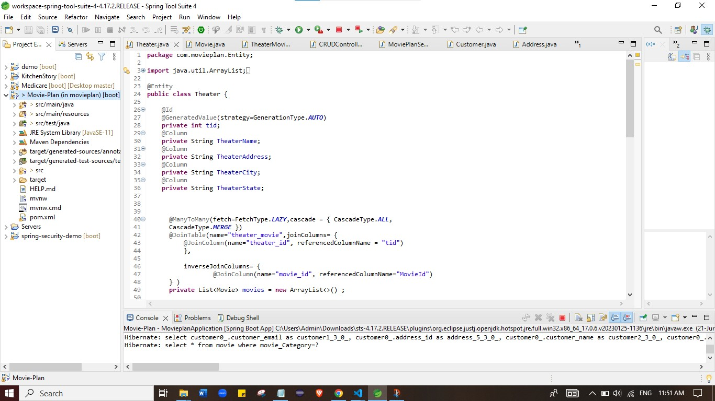

**Login page:**

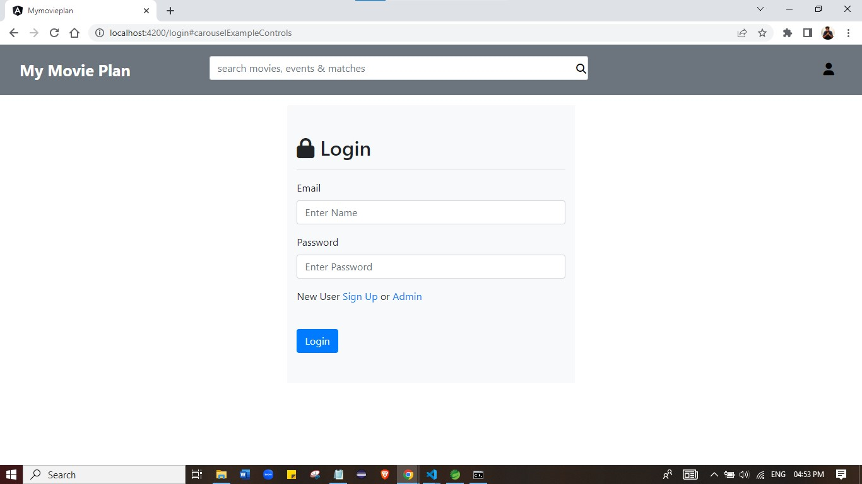

**Login validation:**

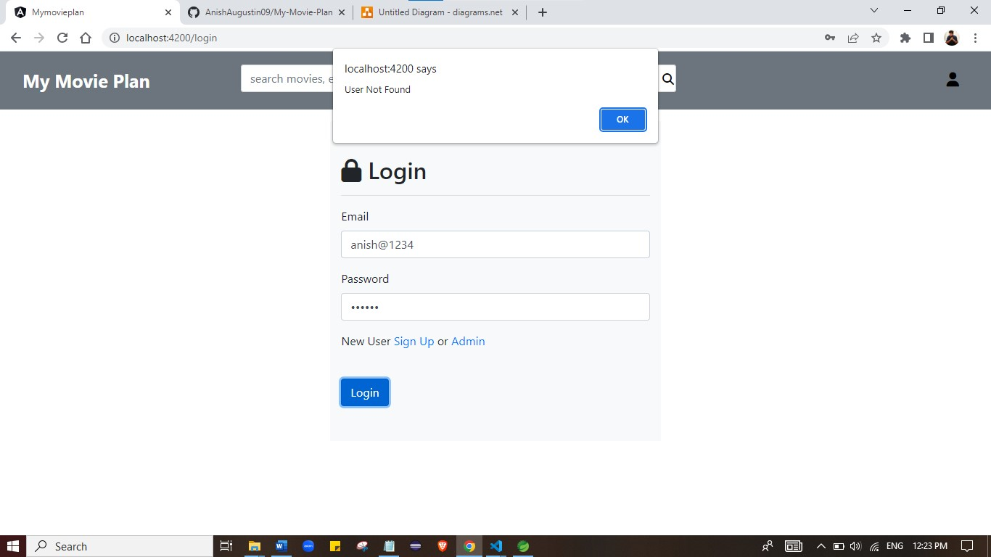

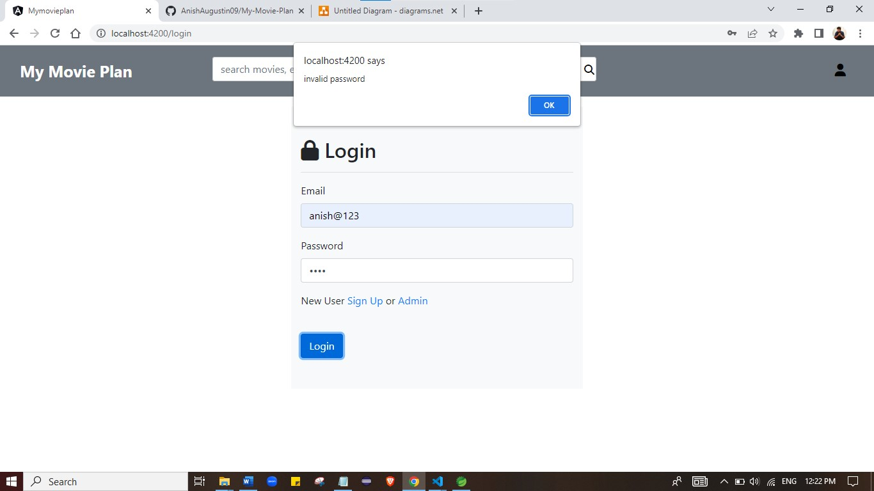

**Register page:**

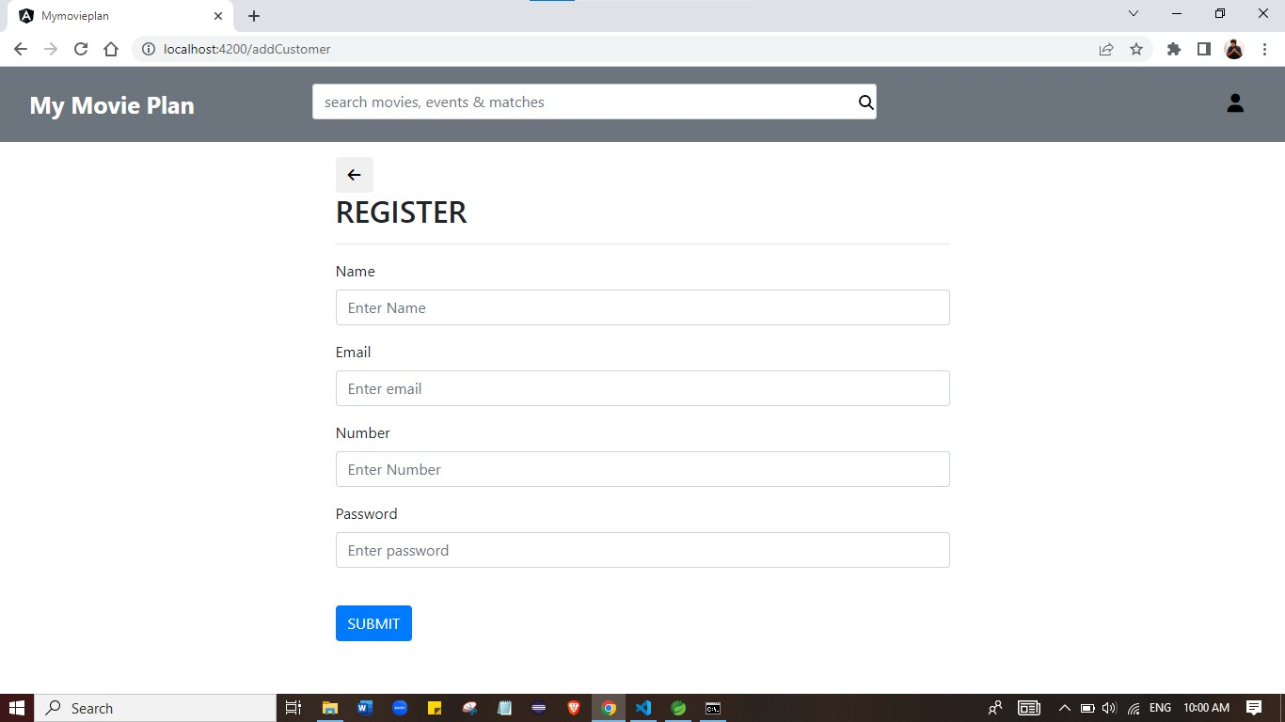

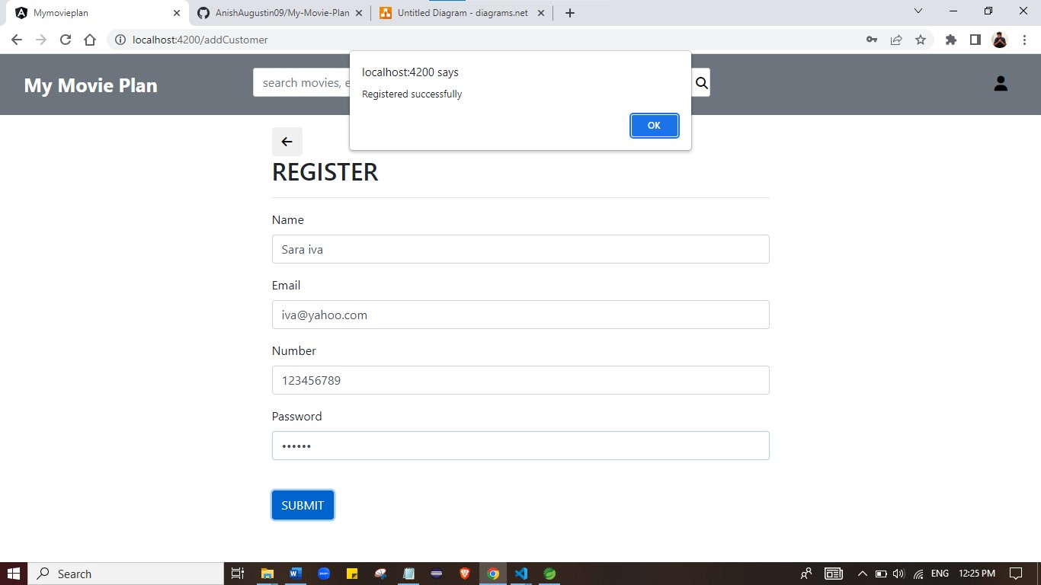

**Login Profile:**

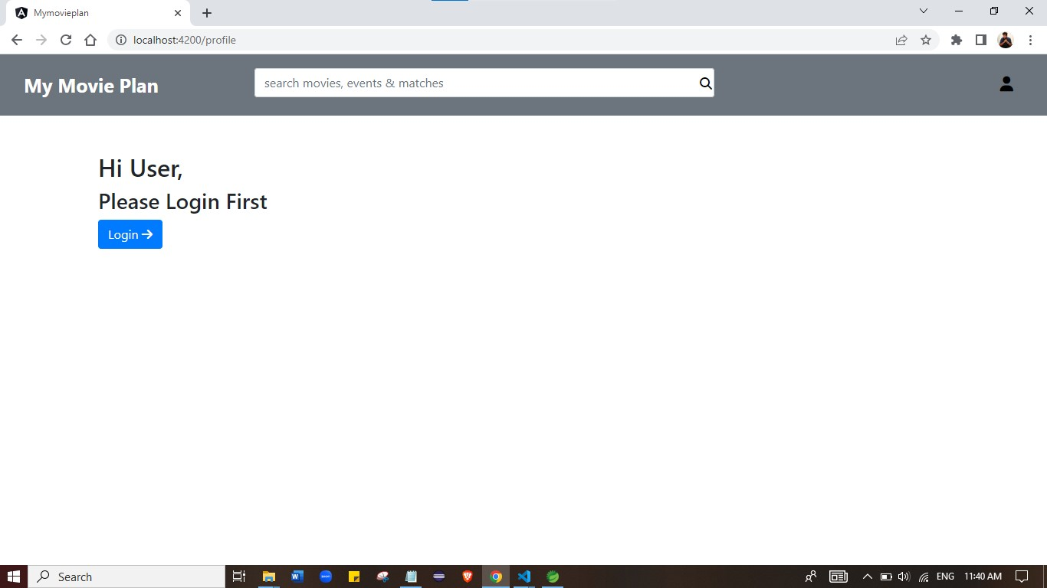

**Home page:**

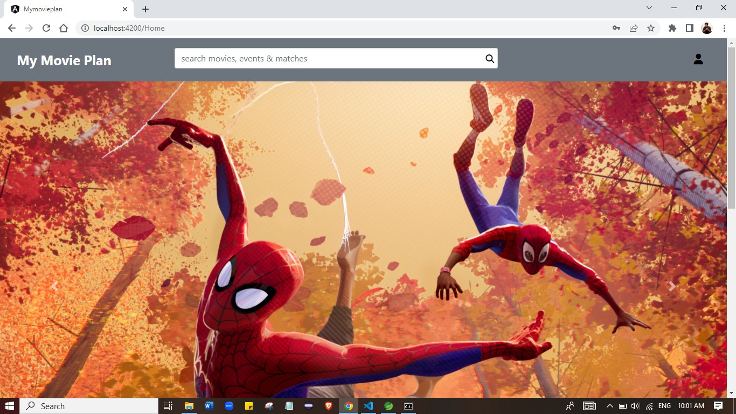

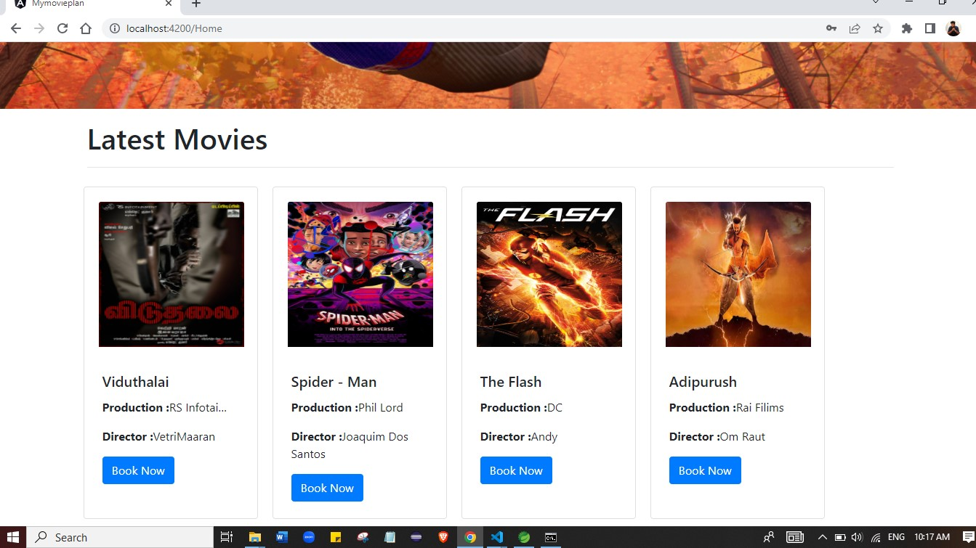

**Profile:**

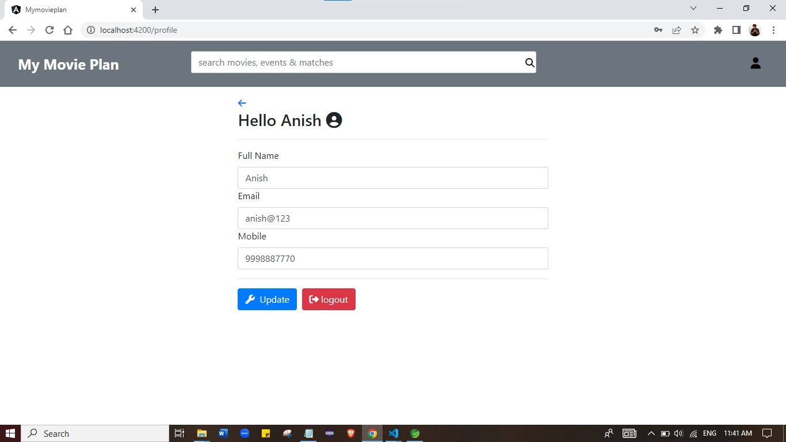

**Logout:**

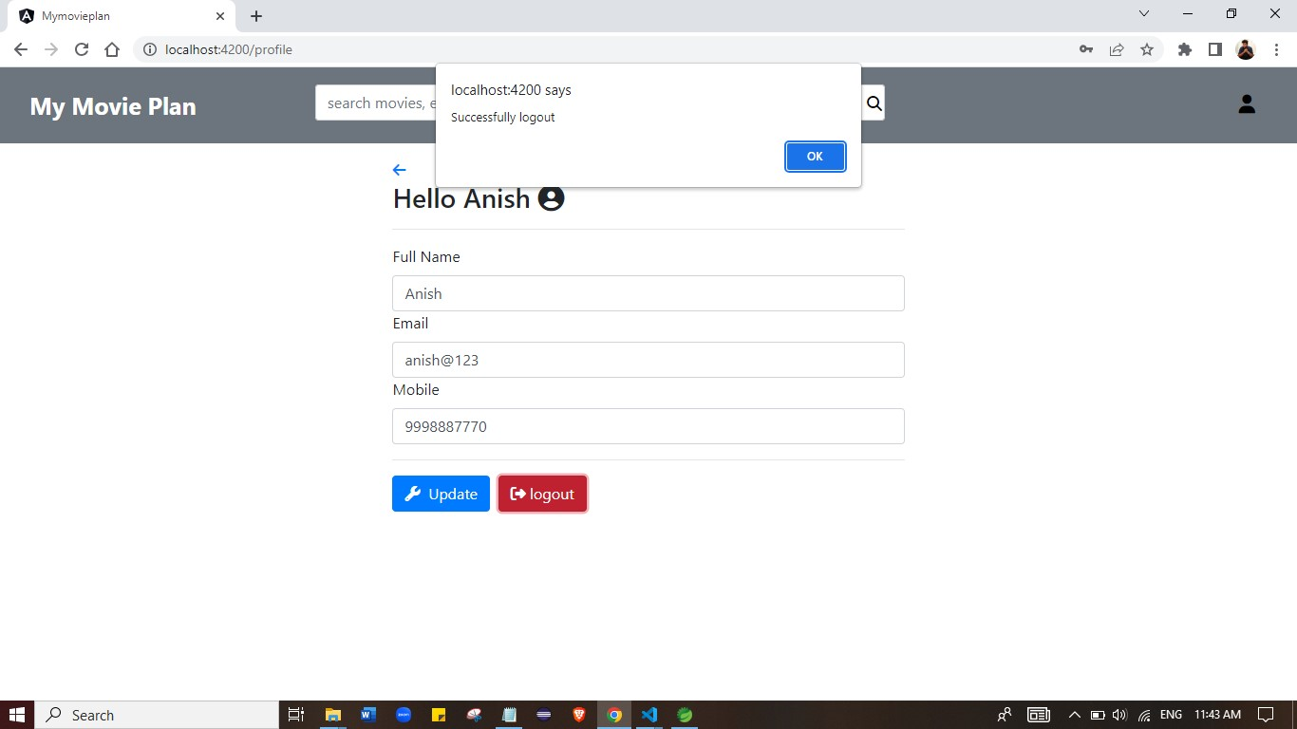

**Theater Selection:**

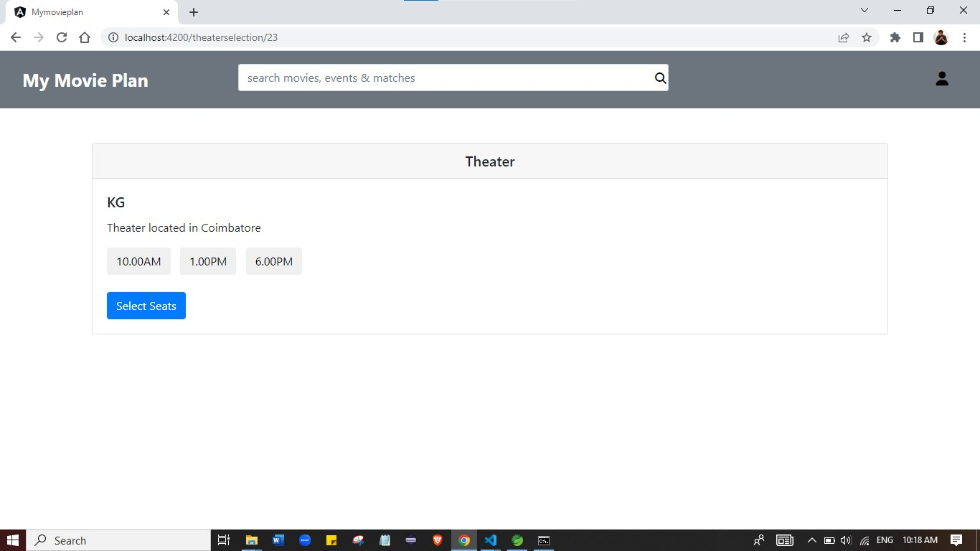

**Seat Selection:**

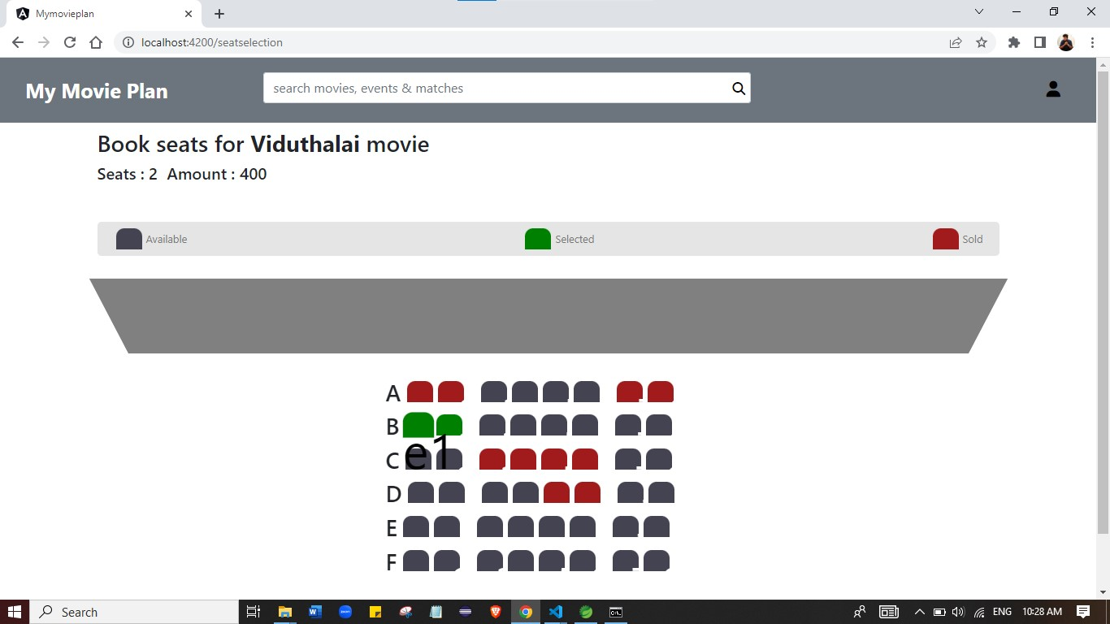

**Payment:**

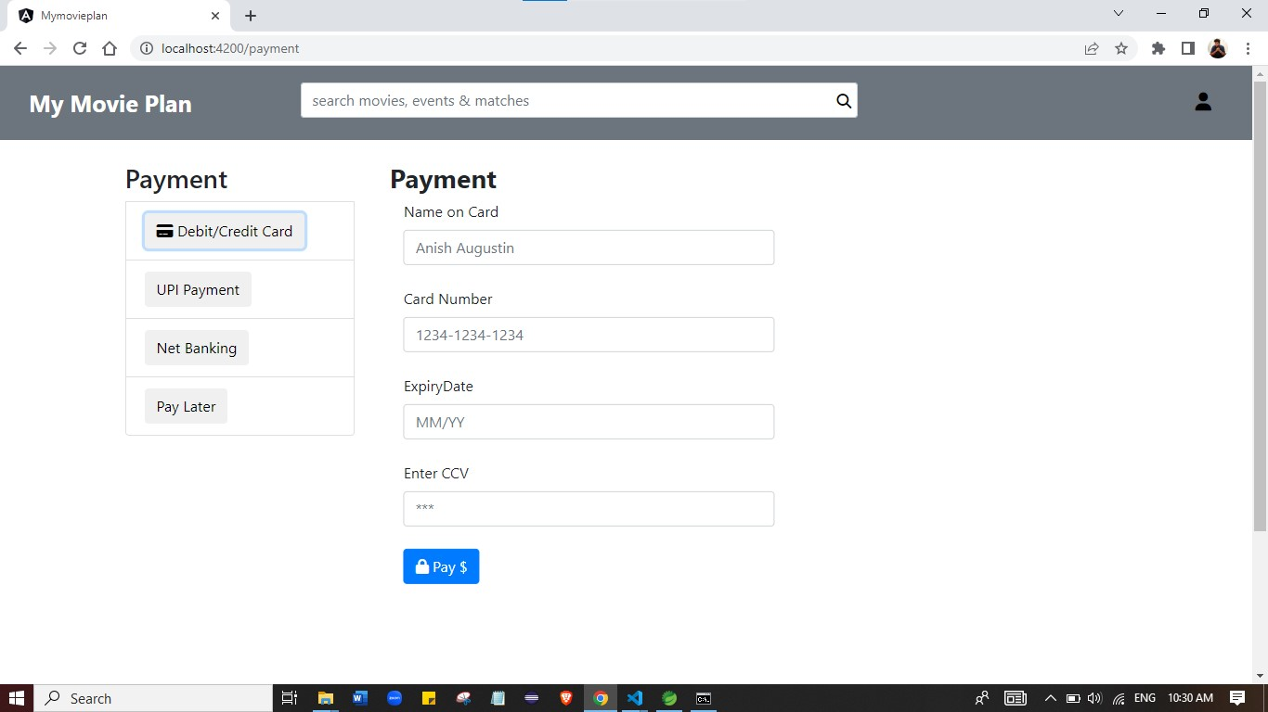

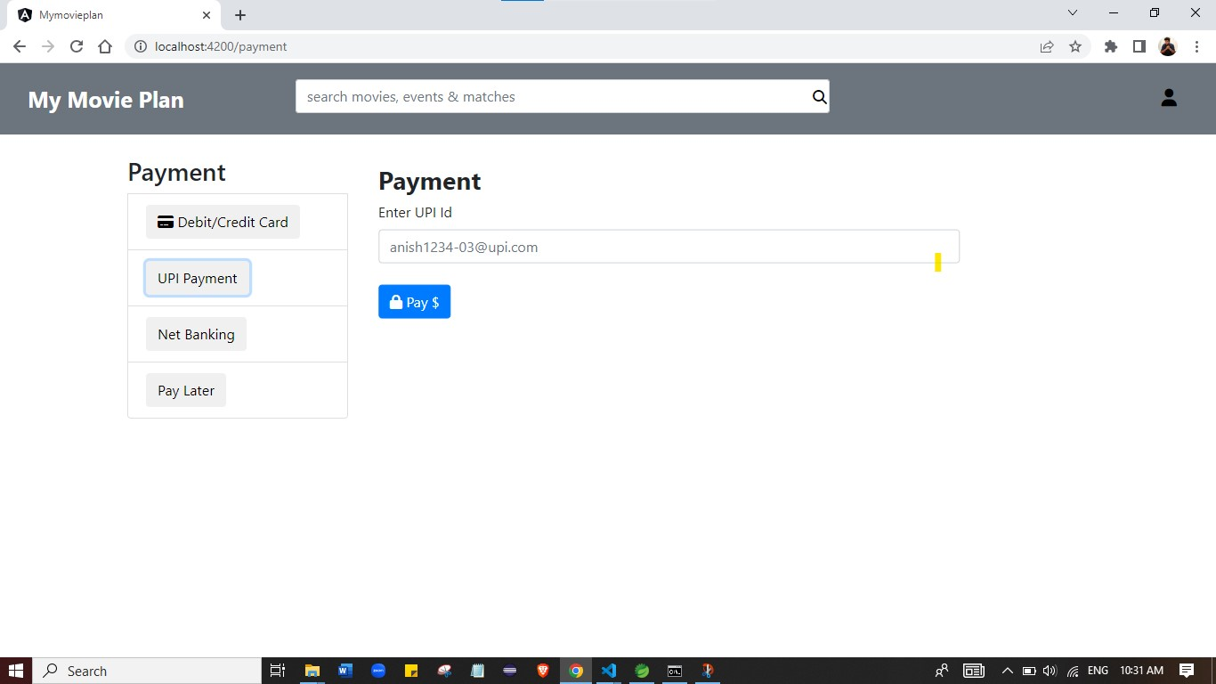

**Booking summary:**

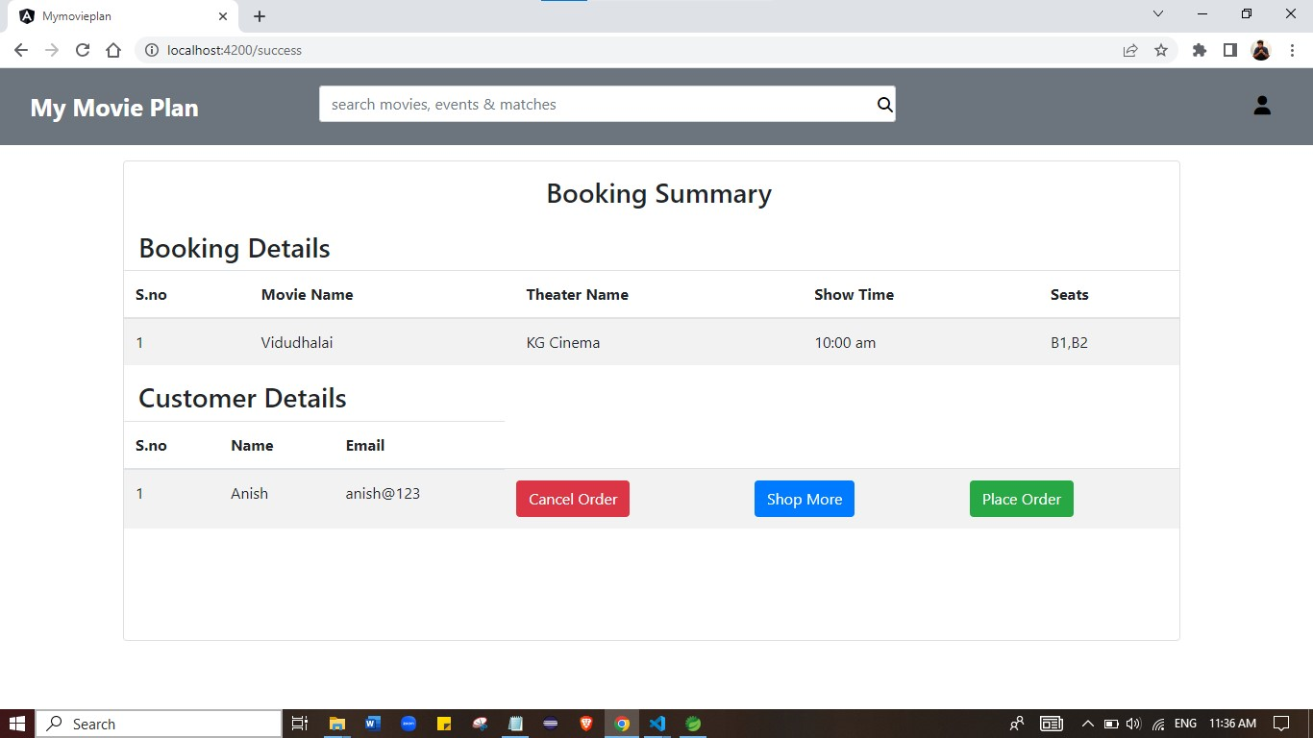

**Booking success:**

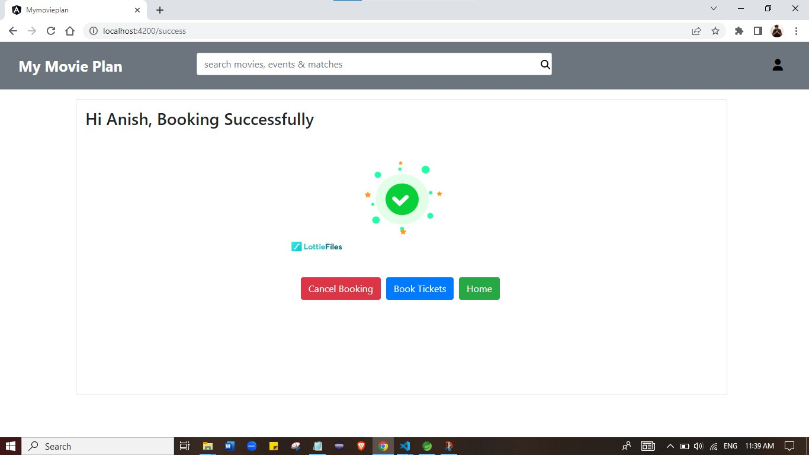

**Admin Login:**

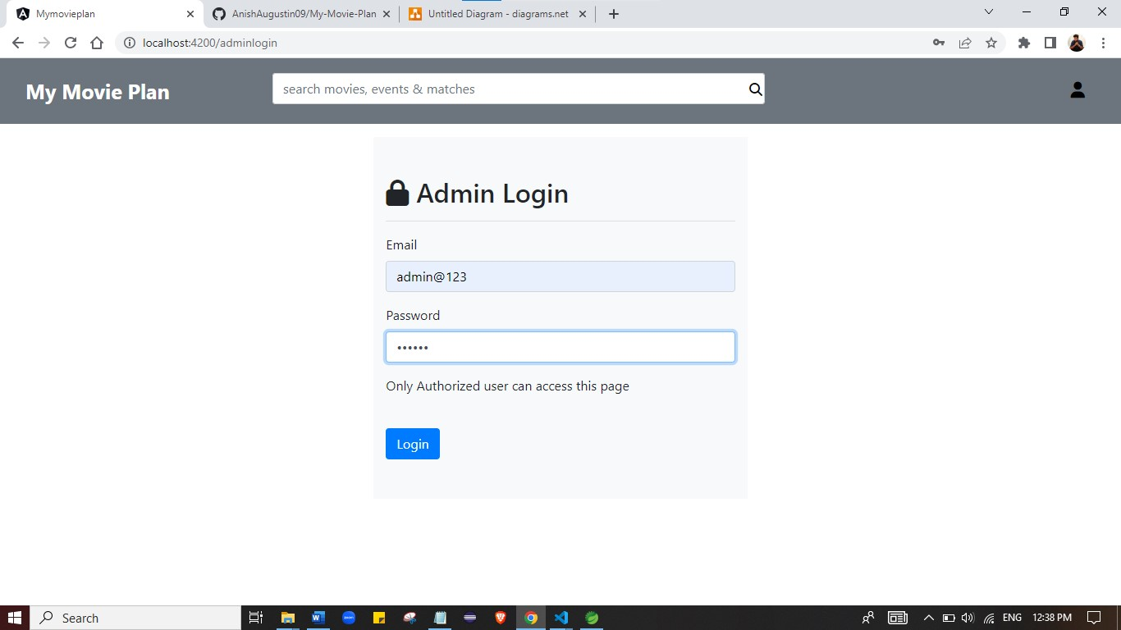

**Admin DashBoard:**

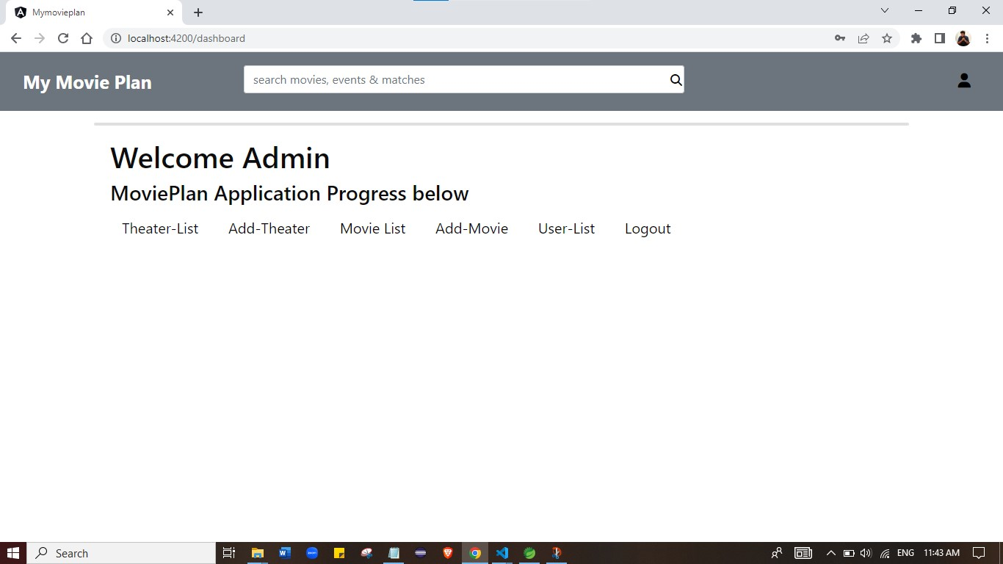

**Add Theater:**

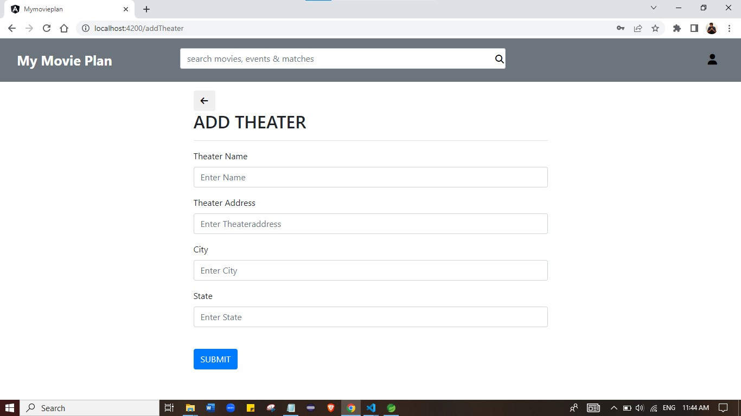

**Add Movies:**

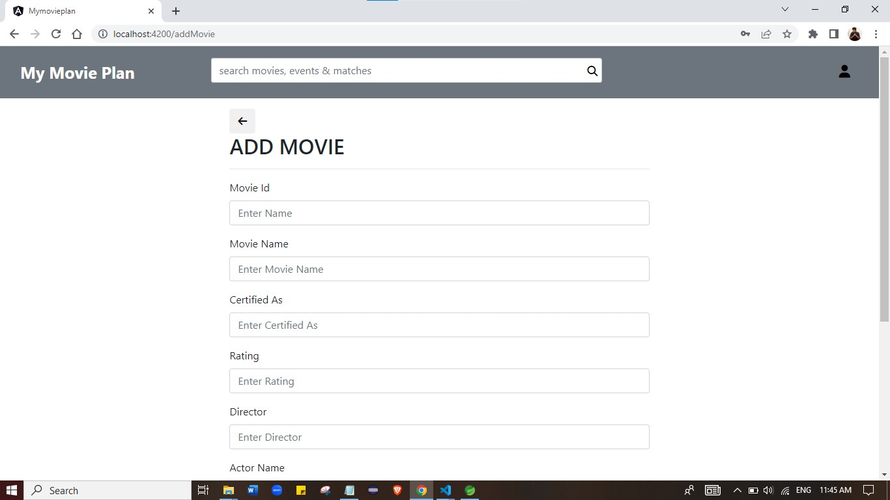

**All Theaters:**

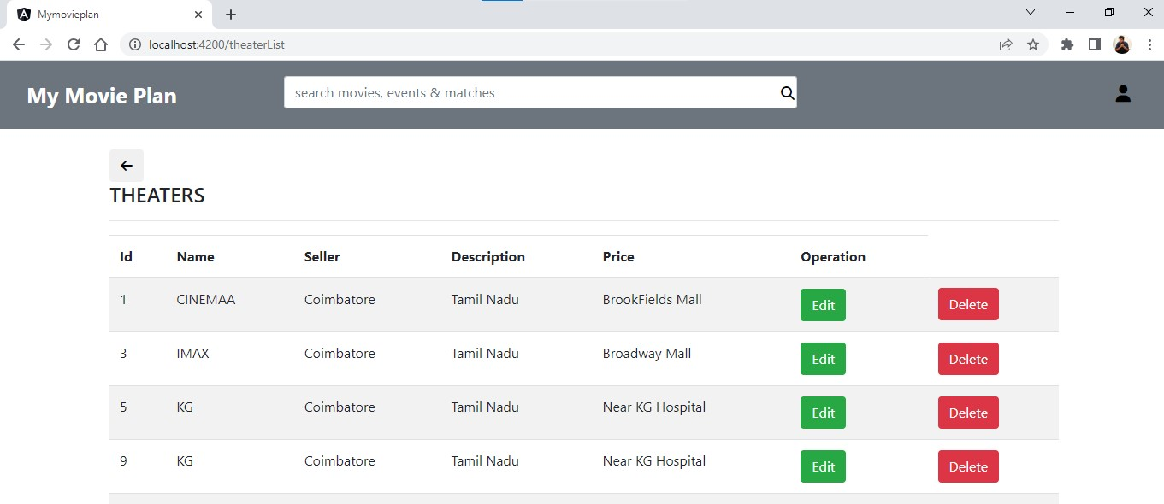

**All Movies:**

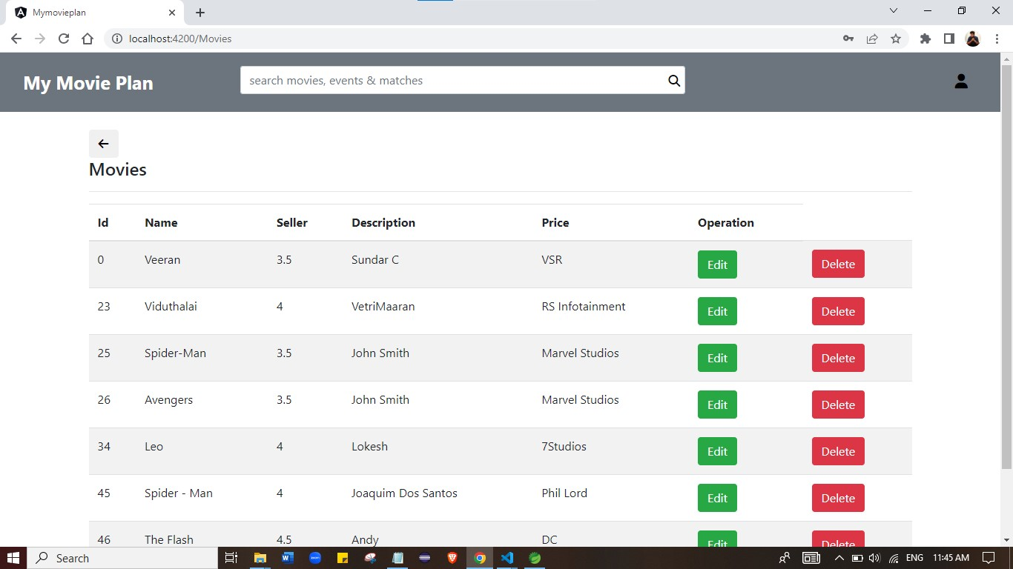

**All Users:**

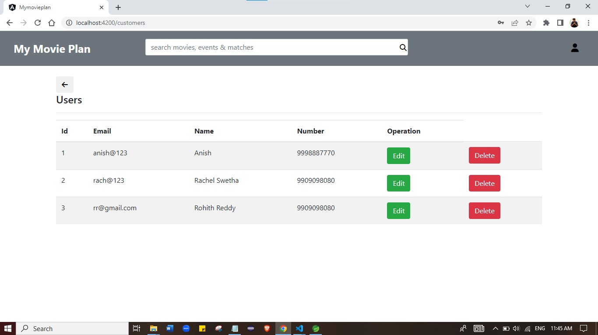

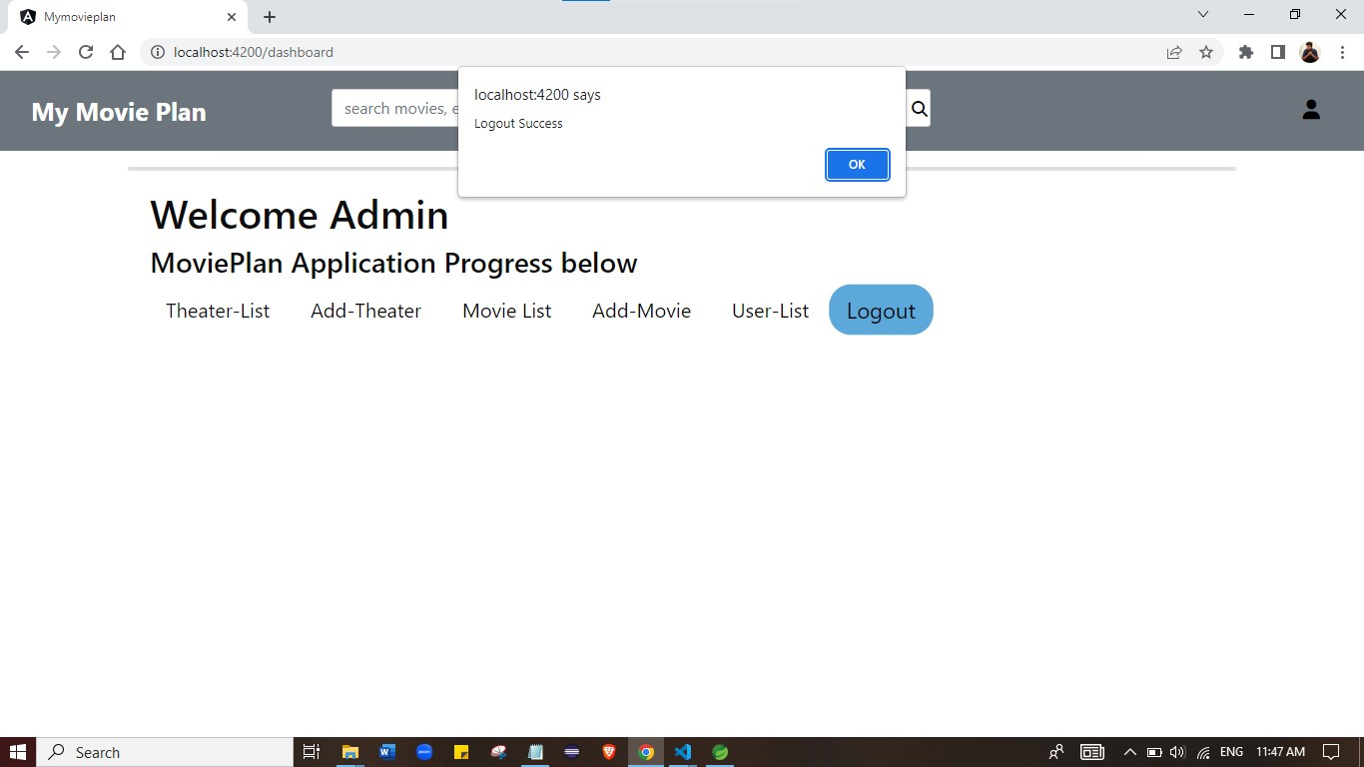

**FINAL SETTING :** Upload files to GitHub Repository

* Open your command prompt and navigate to the folder where you have created your files.
* cd <folder path>
* Initialize repository using the following command:
* git init
* Add all the files to your git repository using the following command:
* git add .
* Commit the changes using the following command:
* git commit . -m <commit message>
* Push the files to the folder you initially created using the following command:
* git push -u origin master

**Unique Selling Points:**

1. This application is use to store & manage the Company products, users & Purchase Record
2. This application will keep on running until user close the program.
3. It allows the admin to add, update , delete, for the products, Users & Purchase Record.
4. It allows the admin to Update Password, Search Reports by date and Category & Search user by email.

**Conclusion:**

Further enhancements to the application can be made which may include

To deliver better Front-end.

THANK YOU